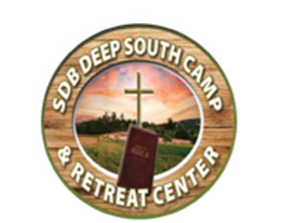

Deep South Camp Worker Information Form
Year: __________

Personal Information
Name: _____________________________________________________________________________________________
Address: __________________________________________________________________________________________
_____________________________________________________________________________________________________
Home Phone: (_____) ______________________

Church Information
Home Church: _____________________________________________________________________________________
Church Phone: (_____) ______________________

Background Information
Have you ever been convicted of a felony? ☐ Yes ☐ No

Affirmation Statement
I affirm that the above information is true and accurate. I further affirm that nothing in my past would prevent or preclude me from serving at Deep South Camp in any capacity, including working directly with and supervising children (ages 8–17).
Camp Worker Signature: _______________________________ Date: ____/____/____

Church Recommendation
We, the members of ______________________________________________ Church, affirm that the above-named individual is of good character and morally sound.
Church Representative Signature: ____________________________ Title: __________

Risk Management Acknowledgment
Date Reviewed: __________________
Camp Worker Signature: _______________________________
Church Representative Signature: ______________________ Title: __________

Child Protection Training Verification
I ______________________________ confirm completion of Child Protection Policy Training.
Signature: ______________________ Date: __________
Trainer: ______________________ Church: ______________________

